Экзаменационный билет №2

Игнатова Светлана 3ПКС-320

**Код программы на C++**

#include <iostream>

#include <string>

#include <cstdlib>

#include <ctime>

#include <fstream>

#include <Windows.h>

using namespace std;

#define ARR_SIZE 3

class Worker

{

public:

string name;

int salaries[10];

int s;

Worker() {}

Worker(string _name)

{

name = _name;

}

Worker(string _name, int _salaries[])

{

name = _name;

memcpy(_salaries, salaries, sizeof salaries);

}

};

int getRandom(int max, int min)

{

int range = max - min + 1;

return rand() % range + min;

}

string allSalaries10(Worker currWorker)

{

string str = "";

for (int i = 0; i < currWorker.s; i++)

{

str += to_string(currWorker.salaries[i]);

if (i != currWorker.s - 1)

{

str += ", ";

}

else

{

str += ";";

}

}

return str;

}

string allSalaries6(Worker currWorker)

{

string str = "";

for (int i = 0; i < 6; i++)

{

str += to_string(currWorker.salaries[i]);

if (i != 5)

{

str += ", ";

}

else

{

str += ";";

}

}

return str;

}

void info_out(Worker currWorker)

{

cout << currWorker.name << ":";

cout << allSalaries10(currWorker);

cout << endl;

}

double average(Worker currWorker)

{

double res;

unsigned int result = 0;

_asm

{

XOR EAX, EAX

XOR ECX, ECX

MOV ECX, 0

BEGIN:

ADD EAX, currWorker.salaries[ECX * 4]

INC ECX

CMP ECX, currWorker.s

JL BEGIN

XOR BX, BX

XOR CX, CX

MOV result, EAX

}

res = (double)result / currWorker.s;

cout << res << endl;

return res;

}

int main()

{

srand((unsigned int)time(NULL));

SetConsoleCP(1251);

SetConsoleOutputCP(1251);

Worker worker1, worker2, worker3;

worker1.name = "Горохов";

worker2.name = "Салтыков";

worker3.name = "Соколов";

worker1.s = getRandom(10, 1);

worker2.s = getRandom(10, 1);

worker3.s = getRandom(10, 1);

for (int i = 0; i < worker1.s; i++)

{

worker1.salaries[i] = getRandom(60000, 40000);

}

for (int i = 0; i < worker2.s; i++)

{

worker2.salaries[i] = getRandom(60000, 40000);

}

for (int i = 0; i < worker3.s; i++)

{

worker3.salaries[i] = getRandom(60000, 40000);

}

info_out(worker1);

info_out(worker2);

info_out(worker3);

cout << endl;

double avg1 = average(worker1);

double avg2 = average(worker2);

double avg3 = average(worker3);

cout << endl;

cout << "Средняя зарплата " + worker1.name + "a: " << avg1 << endl;

cout << "Средняя зарплата " + worker2.name + "а: " << avg2 << endl;

cout << "Средняя зарплата " + worker3.name + "а: " << avg3 << endl;

std::ofstream out;

out.open("C:/Users/Sveta/Desktop/Сотрудники.txt");

if (out.is_open())

{

out << worker1.name << endl;

out << "Зарплаты за 6 месяцев: " << allSalaries6(worker1) << endl;

out << "Средний размер зарплаты: " << avg1 << endl;

out << "----------------------------------" << endl;

out << worker2.name << endl;

out << "Зарплаты за 6 месяцев: " << allSalaries6(worker2) << endl;

out << "Средний размер зарплаты: " << avg2 << endl;

out << "----------------------------------" << endl;

out << worker3.name << endl;

out << "Зарплаты за 6 месяцев: " << allSalaries6(worker3) << endl;

out << "Средний размер зарплаты: " << avg3 << endl;

out << "----------------------------------" << endl;

}

system("pause");

return 0;

}

**Выходные данные:**

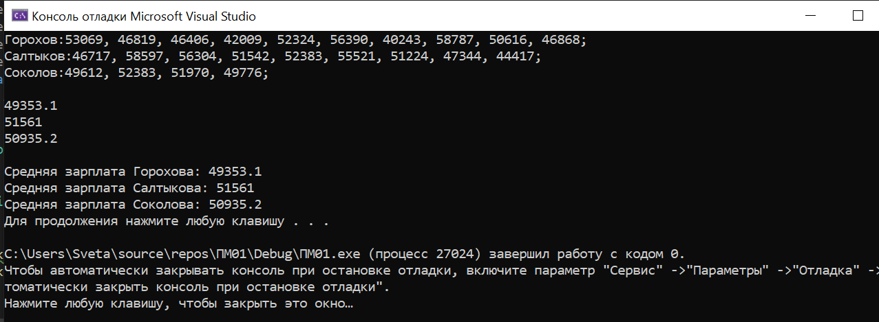

**Вывод в файл .txt:**

